Worksheet 1.2

Student Name: Rydem UID: 25MCI10275
Branch: MCA (AI & ML) Section/Group: MAM-1 (A)
Semester: I Date of Performance: 25/08/25
Subject Name: Artificial Intelligence Tools - I Subject Code: 25CAP-614

1. Aim/Overview of the practical:
Experiment-2:
Implementation of Depth First Search

2(A). Coding:
import networkx as nx
import matplotlib.pyplot as plt

graph ={
'A': ['B','C','D'],
'B': ['D','E'],
'C': ['F'],
'D': ['E'],
'E': ['F'],
'F': []
}

G = nx.DiGraph(graph)
pos = nx.spring_layout(G)

nx.draw(G,pos,with_labels=True, node_color='skyblue', node_size=2000, font_size=16, font_weight='bold', arrowsize=20)

plt.show()

def depth_first_search(graph, start_node):
visited = set()

def dfs(node):
visited.add(node)
print(node, end=" ")

for neighbour in graph[node]:
if neighbour not in visited:
dfs(neighbour)

dfs(start_node)

start_node = 'A'
depth_first_search(graph, start_node)

OUTPUT:-
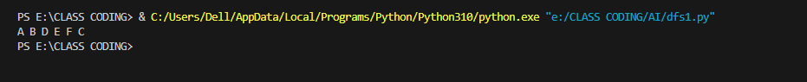
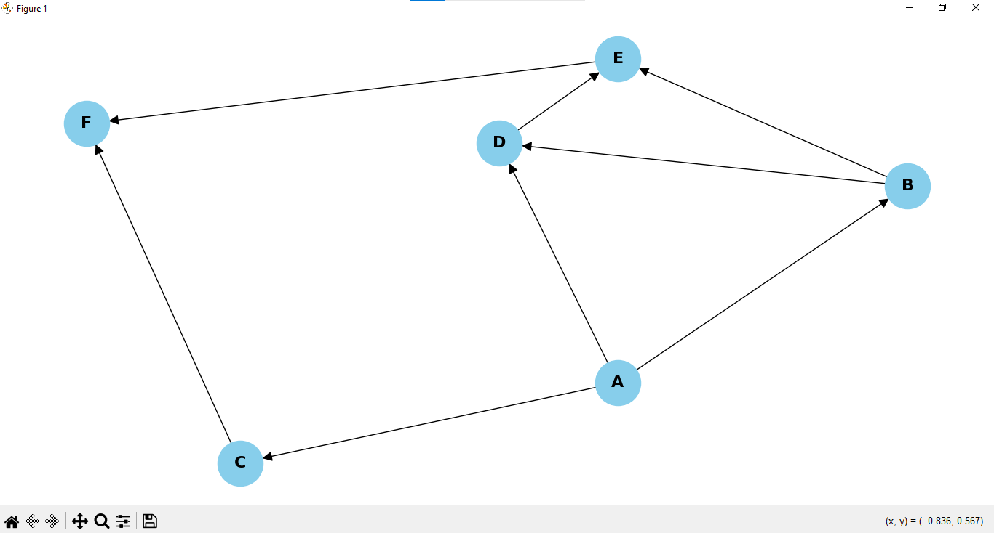

(B). CODING:
import networkx as nx
import matplotlib.pyplot as plt

graph ={
'A': ['B','G'],
'B': ['A','C','E'],
'C': ['B','D'],
'D': ['C','J','I'],
'E': ['B','F','I'],
'F': ['G','E'],
'G': ['A','F','H','L'],
'H': ['G','I'],
'I':['D','E','H','K'],
'J':['D','M','N'],
'K':['I','L','M'],
'L':['G','K','M','O'],
'M':['L','K','J'],
'N':['J','O'],
'O':['N','L']
}

G = nx.Graph(graph)
pos = nx.spring_layout(G)

nx.draw(G,pos,with_labels=True, node_color='skyblue', node_size=2000, font_size=16, font_weight='bold', arrowsize=20)

plt.show()

def depth_first_search(graph, start_node):
visited = set()

def dfs(node):
visited.add(node)
print(node, end=" ")

for neighbour in graph[node]:
if neighbour not in visited:
dfs(neighbour)

dfs(start_node)

start_node = 'O'
depth_first_search(graph, start_node)

(B). OUTPUT:

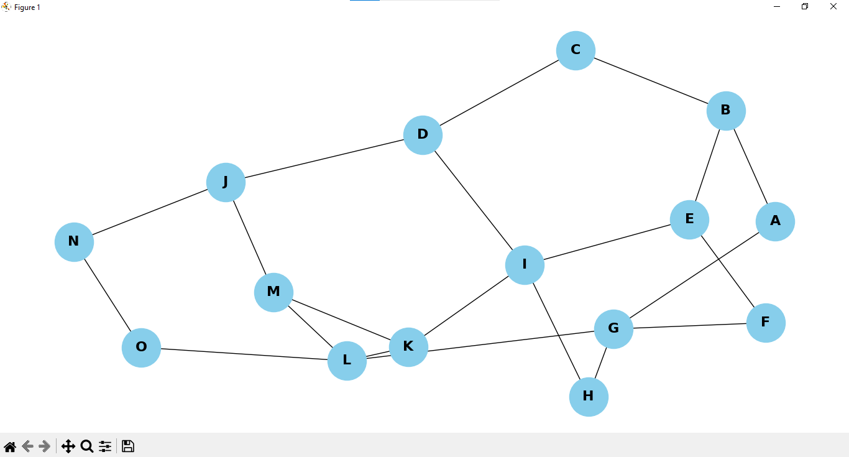

3. Learning outcomes (What I have learnt):
- Understand the working principle of the Depth First Search (DFS) algorithm.
- Learn how to implement DFS using recursion and stack-based approaches.
- Analyze the time and space complexity of DFS.
- Compare DFS with other graph traversal algorithms such as Breadth First Search (BFS).
- Develop problem-solving skills in applications like pathfinding, cycle detection, and topological sorting.

